**SMART INVENTORY &STORE MANAGEMENT SYSTEM**

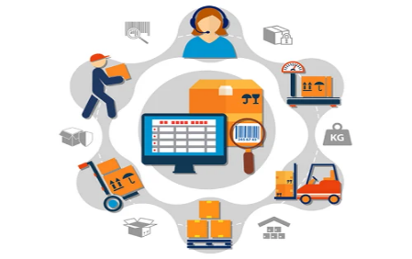

**Team Members:**

KARISHMA K

IMAIYA JOYCE G

JANANI S KIRUBASRI R

KIRUBASRI R

# Abstract:

# This project 'Store Manager - Inventory Tracker' is a frontend-only web application developed using HTML, CSS, and JavaScript without the use of external libraries. The system provides basic inventory management functionalities such as adding, viewing, and deleting products. It also includes a dashboard to display statistics like total products, low stock alerts, and total inventory value. The data is stored persistently using browser Local Storage.

# Introduction:

Inventory management is crucial for businesses to track stock, pricing, and product details. This project introduces a modern approach by designing a lightweight inventory management system

with a stylish dark user interface. The key feature is that the application is completely frontend-based, portable, and does not require any external libraries or backend servers. It is suitable as a college project to demonstrate frontend development skills.

# Objectives:

**The primary objectives of the project are:**

1. To build a web-based inventory management application using only frontend technologies.

2. To implement a dashboard for quick insights.

3. To allow adding, viewing, and deleting products.

4. To store product data using LocalStorage for persistence.

5. To demonstrate core concepts of web development such as DOM manipulation and event handling

# System Requirements:

|  |  |
| --- | --- |
| **Requirement** | **Details** |
| Operating System | Windows / Linux / Mac |
| Browser | Google Chrome / Firefox / Edge |
| Languages Used | HTML, CSS, JavaScript |
| Storage | Browser Local Storage |
| RAM | Minimum 2GB |
| Processor | Any dual-core or higher |

# System Design:

**The system follows a single-page structure. The user interacts with the following components:**

1. Header: Contains project title, Add Product button, and search bar.

2.Dashboard: Displays three statistic cards :Home,cart, inventory, sales add product

3.Product Section: Shows all products in stylish card format .

4.Modal Popup: Used to add new products with fields for name, price, stock, and Tags.

The workflow is straightforward – add products via the popup form, store them in Local Storage, display in cards, update dashboard stats, and allow search/filtering in real-time.

# Output Explanation:

**The application produces the following outputs:**

* Dashboard: Three cards showing key statistics.
* Product List: Grid of product cards with name, category, price, stock, and delete button.
* Add Product Popup: A modal form to insert new product details. - Search Feature: Allows filtering products dynamically by name.

# Conclusion:

The Smart Inventory project successfully demonstrates how a modern inventory system can be built using only frontend technologies. By implementing a dark theme and card-based design, the project stands out from traditional table-based inventory trackers. The use of Local Storage ensures persistence while keeping the project lightweight and portable.

# Future Enhancements:

**The system can be extended by:**

1. Adding backend integration with Node.js and MongoDB.
2. Implementing authentication for admin and staff users.
3. Allowing image uploads for product cards.
4. Generating PDF/Excel reports of inventory.
5. Making the UI mobile responsive with advanced styling.

**GitHub:**

<https://github.com/karishmajk28/inventory>

**Screen short:**

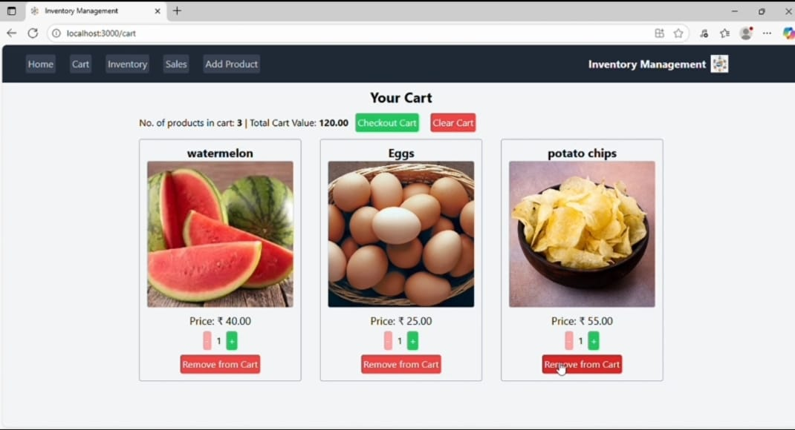

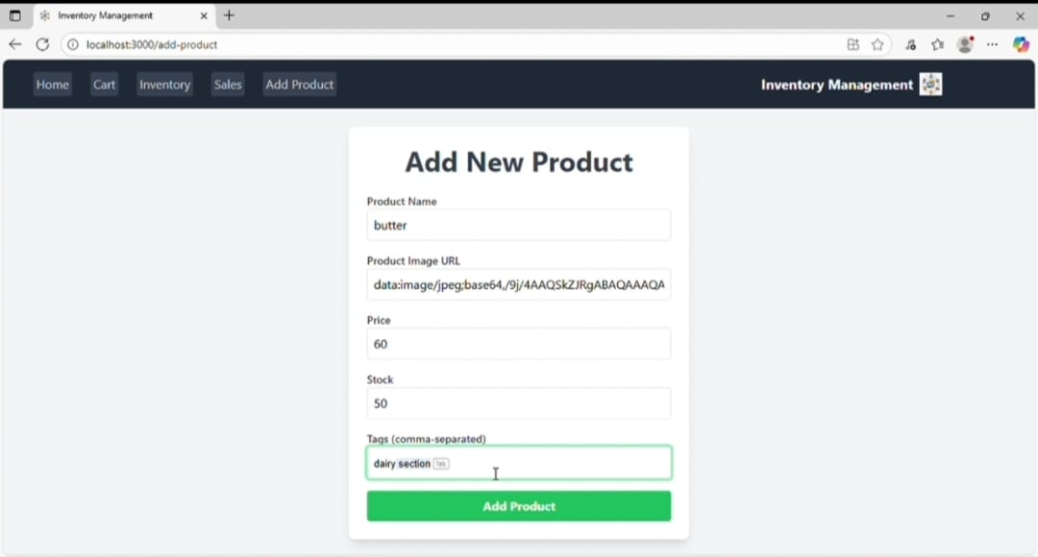

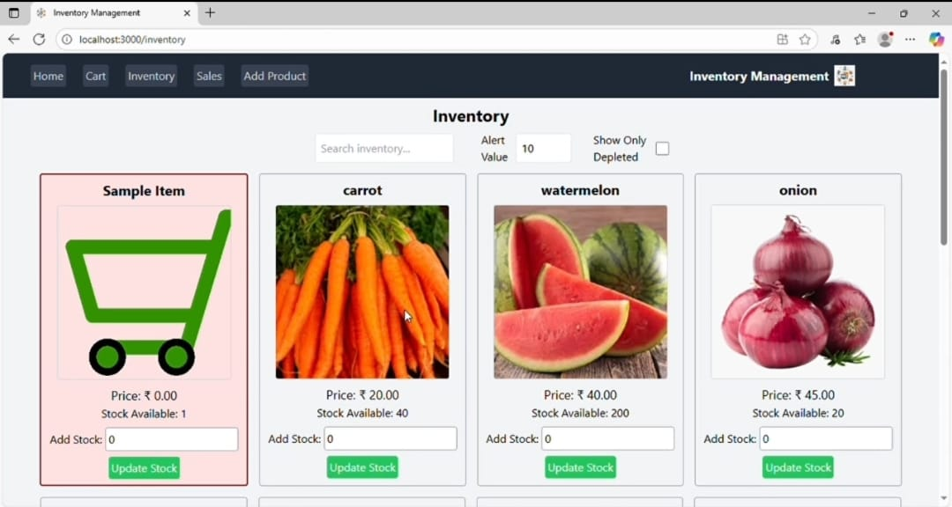



**Video link:**

<https://drive.google.com/file/d/1s_qGPonC2EQDMgdNyInkLyHPT62waBLj/view?usp=drive_link>